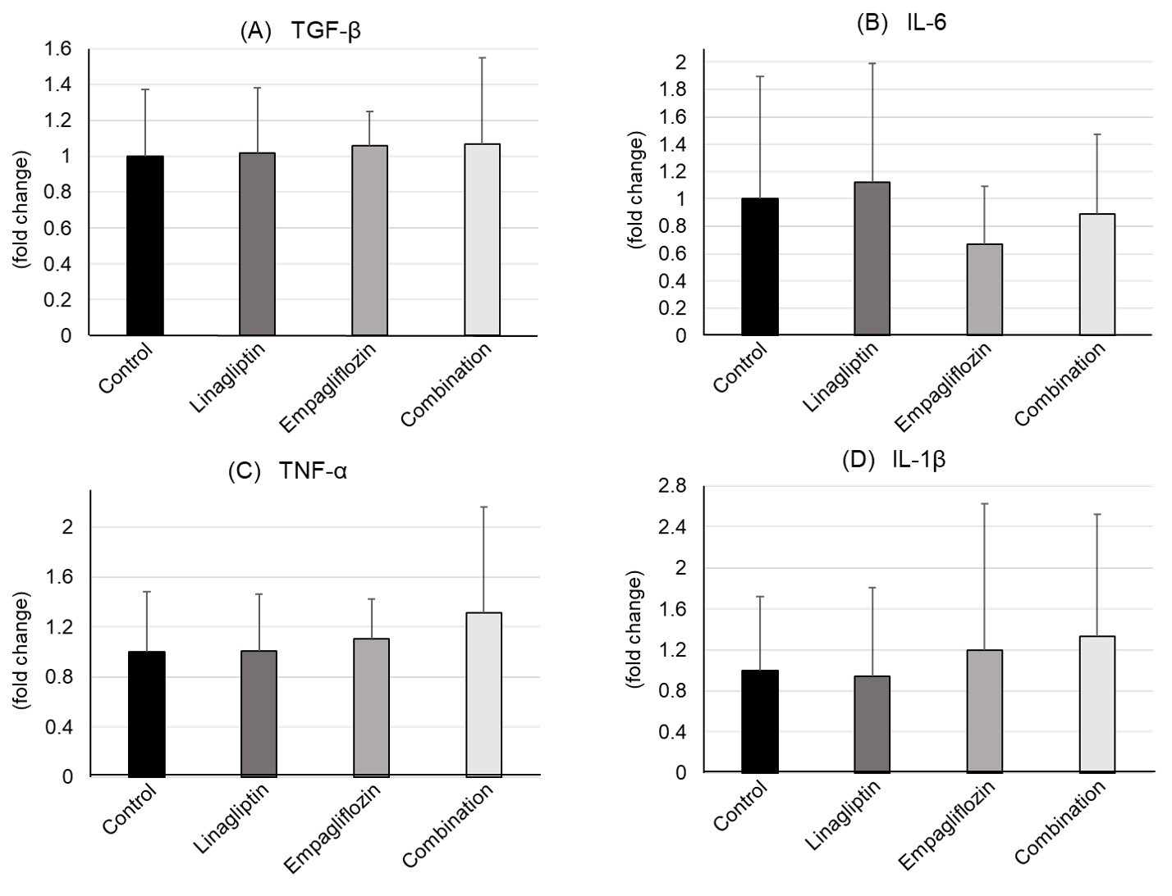
Supplementary Figure 1. Quantitative RT-PCR analysis
mRNA expressions of (A) TGF-β, (B) IL-6, (C) TNF-α, and (D) IL-1β in each group were shown. RT-PCR: reverse transcription–polymerase chain reaction, TGF-β: transforming growth factor-beta, IL-6: interleukin-6, TNF-α: tumor necrosis factor-α, and IL-1β: interleukin-1β. The number of Control, Linagliptin, Empagliflozin, and Combination groups were 8, 7, 7, and 6, respectively.

